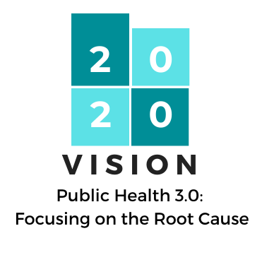
Call for Abstracts

USOPHE Conference
Wednesday, October 7, 2020
SLC Marriott University Park

Due: July 18th at 11:59 PM

USOPHE is currently accepting abstract submissions for the 2020 USOPHE Conference. With COVID-19 there is uncertainty about timing of phased restrictions, we are looking into virtual platforms as a back-up plan.

We are especially interested in abstracts related to the categories listed below. However, we welcome the submission of abstracts related to any appropriate health topic.

- Cross-Sector Collaborations
- Social Determinants of Health
- Health Equity
- Policy and Environmental Changes
- Community Engagement and Mobilization
- Building Resilient Communities (i.e. How to Apply ACEs)
- Local Research and Data Innovations
- Hot, New Health Topics and Trends

Please submit abstracts to Alysia Ducuara at aducuara@slco.org no later than:

July 18th at 11:59 PM

Include the words “USOPHE Abstract” in the subject line of the e-mail. Selected abstract authors will be notified by August 14th, 2020.

Abstract Form

Presenter Name: Click here to enter text.

Presenter Highest Degree: Click here to enter text.

Presenter CHES#/MCHES#: Click here to enter text.

Presenter Current Title: Click here to enter text.

Presenter Current Organization: Click here to enter text.

Presenter Email Address: Click here to enter text.

Presenter Bio (include work and/or research relevant to presentation topic):
Click here to enter text.

Co-Presenter Name (if applicable): Click here to enter text.

Co-Presenter Highest Degree: Click here to enter text.

Co-Presenter CHES#/MCHES#: Click here to enter text.

Co-Presenter Current Title: Click here to enter text.

Co-Presenter Current Organization: Click here to enter text.

Co-Presenter Email Address: Click here to enter text.

Co-Presenter Bio (include work and/or research relevant to presentation topic):
Click here to enter text.

Session Title: Click here to enter text.

Session Abstract (less than 250 words):
Click here to enter text.

How do you plan to engage the attendees in your presentation? (less than 250 words): Click here to enter text.

How long a session would you prefer, including Q&A time? Click on box to mark preference:
☐30 minutes
☐60 minutes
☐90 minutes

Are you willing to do your session virtually, if needed?
☐Yes
☐No

Three SMART Objectives - SMART Objectives are Specific, Measurable, Achievable, Realistic, and Time Phased Learn more about writing SMART Objectives here.

For each objective, you must indicate which NCHEC Areas of Responsibility are related. Find Areas of Responsibility here.

SMART Objective | Related Area(s) of Responsibility  You must include at least one for each objective. (i.e. 1.3.5; 1.5.3)
1.

2.

3.

